**Practical – 5**

**Aim: -** Install and configure a Network Interface Card (NIC) in a workstation.

**What is NIC?**

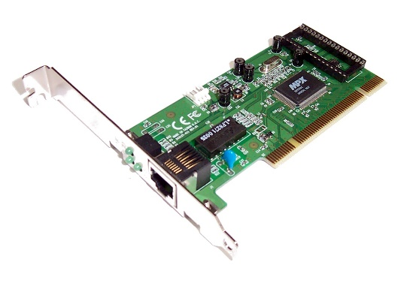Network Interface Card (NIC) is a very useful hardware component for computers. This component is only applicable to computers. This card cannot be applied to laptops. There are two types of internet connection. In one case, using Wi-Fi, we can browse the web servers. In another case, we have to use a wire to get an internet connection. For the Wi-Fi type of internet connection, we need to have a Wi-Fi adapter. The adapter should be plugged into the machine itself. This adapter can be used in both computers & laptops. However, the wired connection is only applicable to computers. In a wired connection, the internet provider provides a wire. This wire helps you to receive internet connections from the authorities. For that purpose, we need to install the Network Interface Card on the device. The wire will get connected to the device. This helps to secure your wired connection. But with time, the wired connection demand is decreasing. This can only be used in computer labs. There are many computers to get connected with the help of this wire. Also, the connection speed will stay in stable format. Using Wi-Fi in computer labs will decrease the speed of the internet. For that purpose, we need to use a Network Interface Card.

**Hardware Installation**

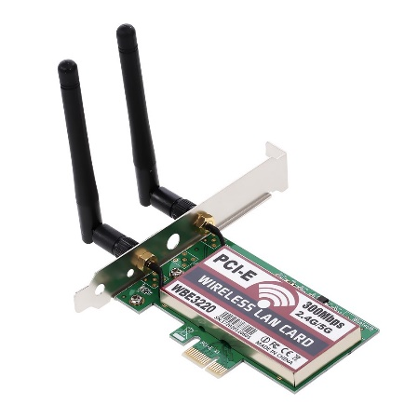Before configuring the Network Interface Card, we need to first install the Hardware. There is a Network Interface Card available on the market. Both in the online & offline market, users can buy the card. There are many cards present. As per the choice of the brand, users can choose any one Network Interface Card. The Network Interface Card comes with a breadboard where the whole component is already assembled. The breadboard needs to be placed in the computer cabinet. We need to open the CPU cabinet of the device. There is a special position present to add the Network Interface Card. We have to carefully join the component to the cabinet motherboard. Now, we have to close the cabinet again. Along with that, we have to also plug in the internet wire to the USB outlet of the Network Interface Card.

**Configuration of Network Interface Card**

1. After successful Hardware Installation, Open the ***Control Panel***
2. Click on the ***Network and Internet***

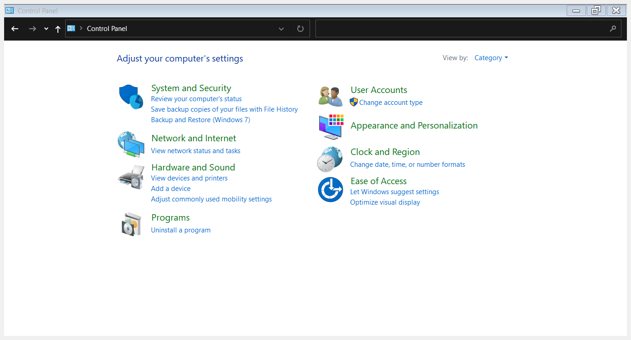

1. Click on the ***Network and Sharing Center***

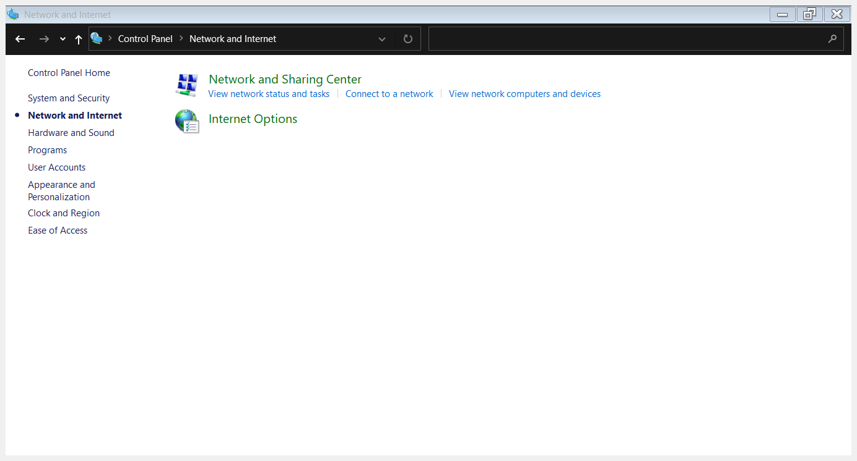

1. On the Left Pane Click on the ***Change Adapter Setting***

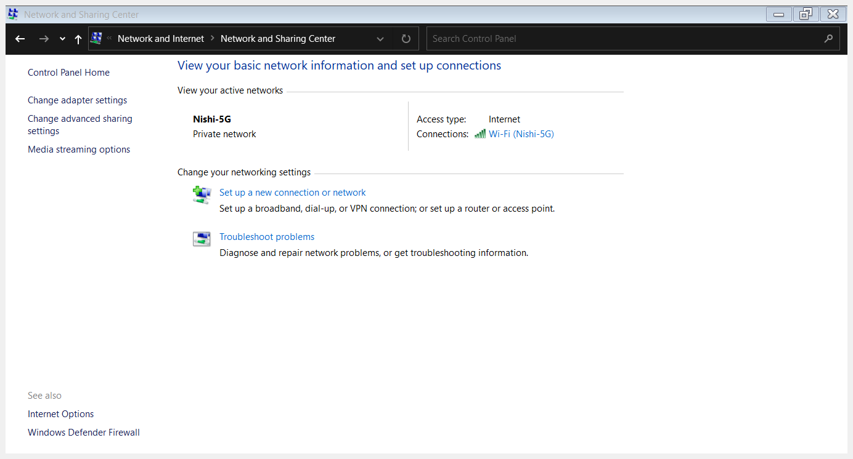

1. On clicking ***Change adapter settings***, a new window opens, showing different adapters connected to your PC. In My Case, I am using My Wireless NIC

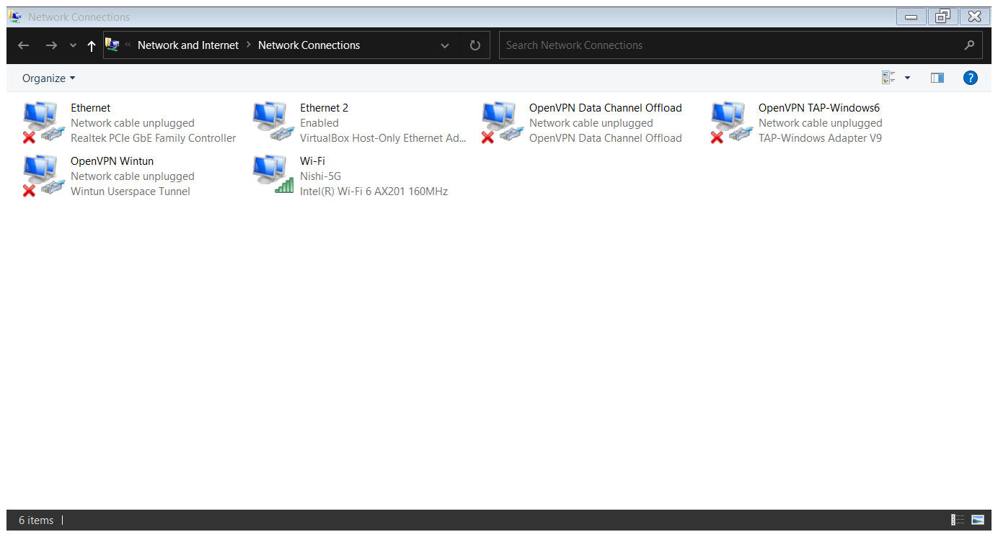

1. Open the ***property*** of your NIC

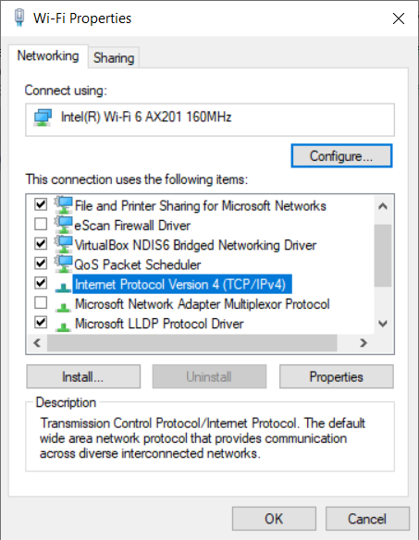

1. Click on the ***Internet Protocol version 4(TCP/IPv4)*** and again click on the ***properties***

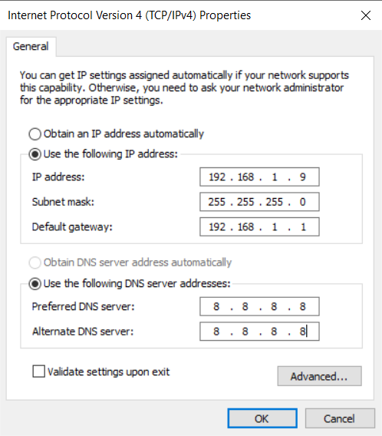

1. Manually enter your ***IP address, Subnet mask, Default gateway and DNS*** and click on ***OK.***
2. Now your NIC is manually setup and can check the status of your NIC clicking ***Status*** on right clicking

